Predicting how cancer patients respond to radiotherapy.

RADIO THERAPY

Introduction: Cancer is defined as an uncontrolled growth of cells and forms of tumours, which can property of proliferating from the site of generation and metastatic to other parts of the body. Therapeutic strategies for treating cancer cells are different types like chemotherapy, radiotherapy, imaging techniques like M.R.I (Magnetic resonance image),UV,PET,CAT scanning etc.Radiotherapy plays a key role in therapeutics of cancer as describing of Radiation, is a technique of detect the cancer cells and treat, rupture the malignant tissue in the surrounding parts using of ionising radiation rays.

The procedure of Radiotherapy describes and defined as, process of radio imaging or ionising radiation to detect and damage for cancer cells and initiating to control the growth of tumours in the human body.
It targets mainly DNA in the cell when it progress to expression. However it kills the suspected cancer cell DNA damage and which transfer the effect to other cells which is normal cells,during this process the effect of ionising radiation rays stop the activity of DNA in normal cells. Simultaneously it causes side effects for the patient. So patients have negative impact on this radiation which would give side effects , produce carcinogens, whereas parlally gives to route for malignancies in the suspected area to which spreads to whole body. However it will clear the invasions from the suspected area and not to spread any other parts of the body. Radiotherapy ,which occupies the major portion of curing the cancers , than of other therapeutic treatments. The detailed step by step process steps of radiotherapy which includes the features and types of radiotherapies, methods, mechanism of action, economic reliability, etc..

PREDICTIVE TESTS:
Before going to the step forward of predicting assay, some mechanisms to be point out in cellular systems. Mainly cellular changes, it may effect on molecular systems, their metabolic path ways like DNA damage or repair, over expression of genes,etc...

DNA repair is a process of updating code,sequence structure or mutational errors with the help of enzymes within the cell, it may happens with environmental changes also.

This would be help full for predicting how patients will respond during the process of diagnosis with invitro assays.

The assays are classified into four major assays which have its own specification with the detail description of individual.

DIFFERENT TYPES OF IN VITRO ASSAYS: The classification of radiotherapies are made by the basic mechanism of DNA repair to over controlling towards radiotherapy and it measures the DNA repairs in normal and cancer cells. The assays are divided accordingly into four types of their procedural steps as fallows…

- Clonogenic assay
- Gamma –H2AX assay
- Comet assay
- Micro Nucleus assay

- The above assays are in classified according to their suitable cancer screening of particular cancers, it characterised according to their procedure , time consuming process, economical configuration, acute and specific. The further description of each Microarray nucleus assays quite specific and accurate...

CLONOGENIC ASSAY:

Clonogenic assay is simple technique to check the sensitivity of cancer cells or tumours of which is treated with the cancer therapeutic drugs or radiation therapy.

It was observed in invitro by several radiobiologists and comparing the specificity and sensitivity of tumour cell lines. It is very specific and sensitised test for the screening the cells. This is the simple and quite economic, but time consuming procedure.

It is described as standardised assay for estimating the drug treated or radio ionisationed cells , it have a capability to trace in minute percentage quantities it mean less than(< 1%).

The procedure of this assay is collecting the sample of biopsy/skin, separating the suspension of cells into the agar medium of petry dishes, let it be incubated for 14 days, observe the colonies has formed.

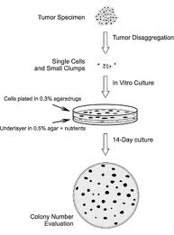
Figure 1: Method for clonogenic assay

It Ref: www.journals.prous.com

The above image is showing the step by step process of clonogenic assay from suspected tumour specimen to in vitro culture technique by a14 days incubation process in a culture medium where colonies has grown in the petry dish.

Figure 2 : Observation and differentiation of colonies in petry dishes.

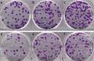
Ref:www.nature.com

This figure explains about the colonies has formed during 14 day incubation at certain temperatures, it clearly represent that reduce the chemical agents level in cell and allow the development survival curve with graph.

Figure: 3 cell survival curve

The below curve is showing the quantity or measurement of cell survival in clonogenic assay against for gamma radiation, where as the percentage of survival of cells in the 1st , 2nd and 4th of gamma rays it was decreasing. The standard errors were calculated in each and every dose.

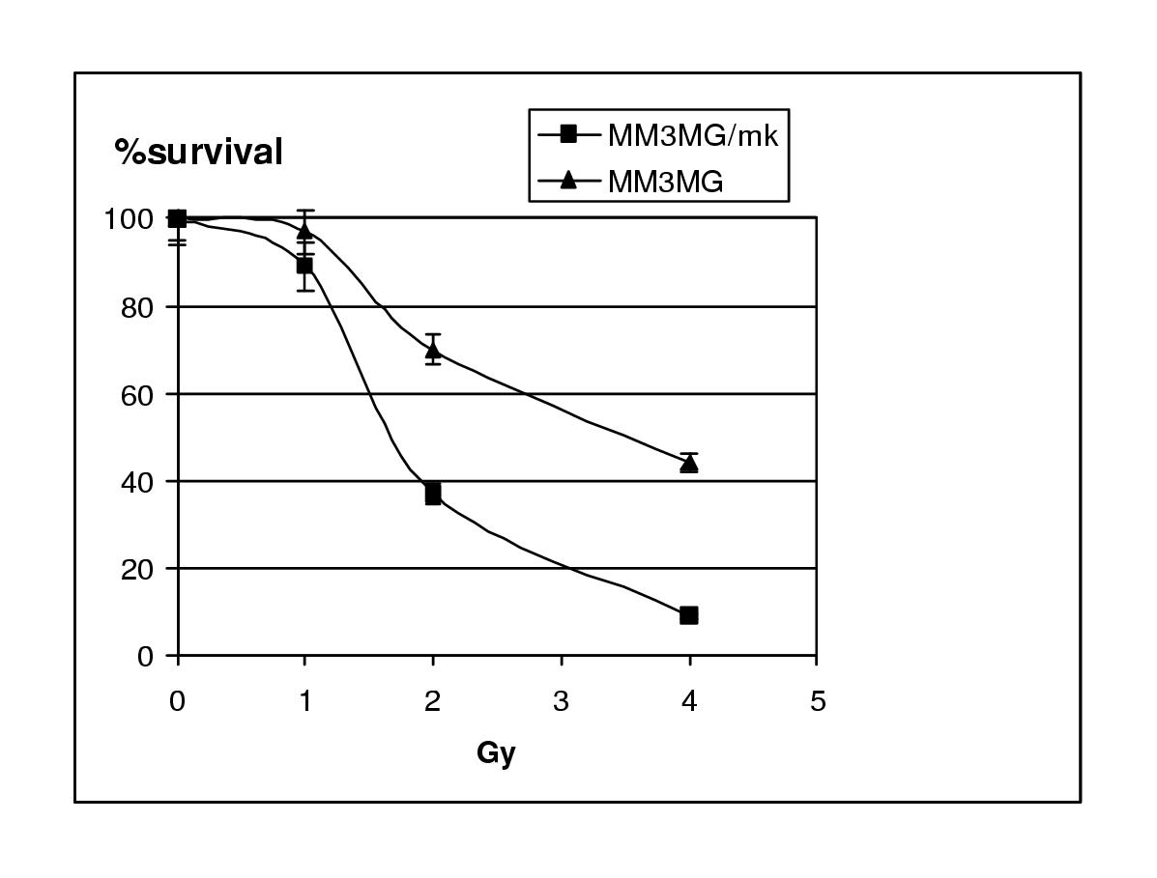
Observations:

During explaining the procedure , performance of this assay it has notified that the clonogenic assay is very specific , accurate for this screening therapeutic radiation or therapeutic drugs in cancer cells.Due to the lengthy procedure and incubation period. This assay is quite expensive and reliable for the mankind.

II. COMMET ASSAY:

Commet assay is the simple and rapid assay for the detection of single strand breaks DNA base pairs in each individual eukaryotic cells. It can be quantify by using simple biochemical technique of electrophoresis, even it refers as Single cell gel electrophoresis, we can estimate the visualisation of DNA damage in eukaryotes.

This assay is developed by sweedish scientist called ostiling and johason in 1984, later 1988
it has modified by singh using alkaline agents.

This assay can be used for the detection of genotoxicity and estimated chemoprevention. It can be used for the quantifying of single strand,double strand,oxidative base damage,DNA cross linking with DNA or protein.

Figure: 2.1

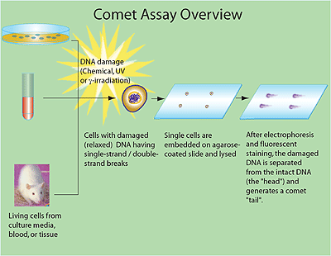

General Overview of Comet assay. Ref: www.sigmaaldrich.com

Comet assay have several steps involved in the procedure like Slide preparation, electrophoresis, neutralisation, DNA staining and visualisation, last is evaluation and interpretation.

The above image is showing the brief description about Comet assay which damaged DNA (sculptured with natural agents like UV ,gamma irradiation) it can be induced in living cells from blood or tissue. These cells are extracted from the living organisms like mouse which are induced with UV, irradiation rays ,etc...

The further procedure if this experiment is embededment of single cells on agarose coated slide . these lysed cells separated on electrophoresis , which is in fluorescent staining of DNA separated from head of the DNA , it generates tail like structures. It has clearly showed in below image..
Fig:2.3

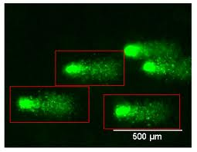
The Figure 2.3 shows tail like structures of DNA fagemnts of base pairs,which has prolonged tials of comet analysis.

The earlier version of comet assay is alkaline comet assay whch have a capability of quantify of mixture of d strand and damage DNA, It is lengthy procedure to incubation, preparation of slids, denaturation of cells like lysis etc....

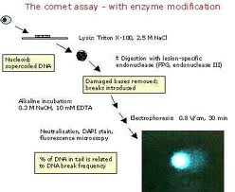
Fig: 2.2

Increasing the capacity and versatility of comet assay.
Ref:www. comics.vitamib.com

The image explains the entire peocedure with Enzyme modification,it evaluated from living cells.
Comet assay is have versatile specification about collecting the data for individual cell, it have high sensitivity detect DNA damage ,needs small amount of cell sample for detecting, use of eukaryotic cells for using specimens both in vivo and in vitro.

III.MICRO NUCLEUS ASSAY:

Micronucleus assay is a screening for toxic substances in the cytoplasm, it is a mutagenic test for the diagnose of chemicals which initiate the formation of DNA fragments. These are the derived from the cytoplasm by departed chromosomes which don’t have the centromers while during the cell division, especially in Ana phase.

The main aim of detecting this assay is to observe the chemical substances which modifies their structure and segregating the telomere of chromosome in the cell division.

PRINCIPLE:

the doubling of nuclei in the cytoplasm which cells are cultured in the medium with or without metabolic activities, whereas cyclochalasin B coated.,during this damage of chromosomes or bi nuclei in the interpahse of cells.

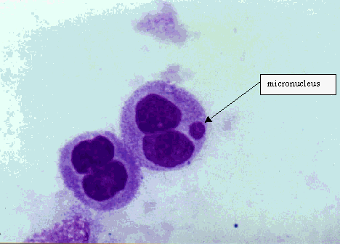

Ref: www.crios.be/genotoxicitytests/foto_mn.gif

Fig III a: above figure shows the forming of micronuclei in the cell during metaphase/anaphase.

Fig III b: schematic path way of cell modifying as micronuclei during certain incubation time with the adhesion of cytochalasinB as an inhibitor.

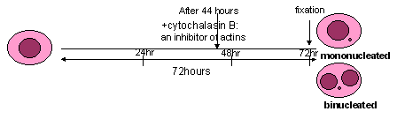

Ref: www.crios.be/genotoxicitytests/foto_mn.gif

Micronucleus assay is to promotes DNA strandbreaks,causing chemical agents. It has been used in the early days for predicting anticancer therapy in patients,due to some over expression of bi nuclei , while increasing the concentrations of chemical agents it ahs showing the multi nucleated cells. Which is gives more DNA damage, Positive cases in the screening time ather than negatives..

This is also have some restrictions as the other assays for the predicting therapeutics…

Here some images of Micronucleus assay showned the binucleated, more expressive in to chemical agents.

Micronucleus test characteristics:

- This is an biomarker for cancer , its very hazard of cancer assessment.
- Main aim to riggert the gene mutation in the cytoplasm
- It have ascentric fragment, its prejudice between mononucleated and binucleus in the cytoplasm.

Mononucleated cells rupture before the cultivation, whereas binucleoted cells rupture during the cutivation and expression of damage. Here find out the some criterias about positive and negative aspects of micronucleus assay. Fenech M et,al Lymphocyte culture(2001

Micronucleated assay | Advantage | Disadvantage
Along with/without Cyto B | Aproaches between cell to cell.  Detect chromosome and genome mutations.  It is very economic, very easy.. | It detects structural chromosome only.  It requires cell division for expression of Micronucleus.
With Cyto-B | |It clearly differs the spindle fibres, nucleoplasmic bridges.  It induces the cell proliferation | Most of chances to get cyto B with chemical inducing.  Interferance of inhibitor of cytokines.

IV.GAMMA H2AX ASSAY:

Genes are the herited which transforms to generations to genarations.Chromatids are the structural filaments in the cell< which have DNAs. Histones are the protein filaments, which DNA is round up these histone structures, it forms foci like structures.

These Histones are classified into four basic classes named as H2A,H2B,H3,H4 and H1,whereas H1 has very less specific function.These histones are plays major role in cellular metabolism in mammalian cells ref by (Fernandez-Capetillo et al., 2004).

H2ax Histone: The H2a family of histone have subtypes of H2A1,H2A2,H2AZ and H2AX . It is an actual isoform of H2Ax. Wheras theseplays a major role in mammalian cells and it occupies major portion like 25% of mammalian histone pool. Imdadhu Rakiman et,al Gamma H2Ax assay(2008).

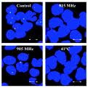

FigIV a: The figure shows about H2ax Histones in different wavelenghths.

Ref: www.iddd.de/umtsno/emfkrebs/4stress.gif

The main function of the H2ax Histone involve in the DNA repair, its defect syndromes, cell growth,immnuoreceptors,etc.. H2ax is phosphorylated in dna strand breakstrand s and participate into some cellular metabolic activities.it is phosphorelation induces ataxia talasenia related proteins(ATR),these fragment initiate to DNA dependent protein kinase. The hypersensitivity of histones be induced DNA double strand breaks.

It has noticed that H2ax is very important for DNA repair and damage, when it overexpress chromatin structures of DSBs form nuclear foci.

H2ax assay is widely used in the estimating the amount of double strand breaks with the ionising radiation and agent with the repair kinetics. It is major marker for the screening the therapeutic agents using in bothcancer cells and normal cells, using invivo and invitro.

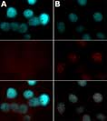

FigIV b: it show the phosphorelated figures of H2ax assay , whereas these cells are phosphorelated withserine 135 .

H2ax assay is have some quite features about the procedure time , which it takes that couple of days procedure to formation of focis. It is very reliable and economic to use.

Some of the equipments using in this experiment like flow cytometry for estimating.

Major features of each individual assay:

lonogenic assay | gammaH2AX Assay | Commet Assay | Micronucleus assay
1.It is simple and measures the sensitivity in cancer therapeutic patients.  2.it works on ionised radiation for repair , ehich colonies formed under certain itme of incubation. | 1.It is histone protein involved for the Dna repair ,damge kind of things.  2.it is phophorelates for the concerned repair,etc. Whereas here it takes less time. | 1.It is also simple and rapid test for the detection of genetoxicity.  2.comet assay works on the electrophoresis. | 1.Micronucleus assay is using for the chromosomal , which detects chromosomal abnormalities ,nuclei was formed.  2.it damages the chemical mutagens in the cytoplasm.

How would radiotherapy is lethal for some Patients:

Radiotherapy is the give less pain to patients while treatment, which directly triggers the suspected area in the where tumours are there. After treatment it may causes the side effects for patient, depends on the type of cancer suffered by the areas. Most of time the radion ray work on the tumour s, due to certain cases it may effect on the health cell which is surrouns the tumour. Due to this repair, DNA damage occurs in healthy cells , for this symptoms of irritation,itching,loss of hair,etc..

CONCLUSION:

Cancer is characterised by malignancy, which travel in the flow of blood to other parts of the body. Radiotherapy is the one of the therapeutic strategies in oncology which patients are treated with this. It very specific and sensible on the target area, but some times it may causes to other cells of the tissues. While during this treatment some screening methodsusing to predict the sensible for the treatement. The predictive assays are Clonogenic assay,comet assay,micronucleus assay, and Gamma H2ax assay, these can predict the therapies.
These assays are very simple and quite procedural assays. Due to certain circumstances,induced chemical agents the DNA repair, damage occur in the cells.

Among the four assays ,H2ax assay is quite economic, reliable assay which can easily acceseble to mankind,interms of results it resembles the accuracy …to be conclude radiotherapy is specific and reliable therapy,predict the lethal to patients with these assays.

References:

- Harrison LB, Chadha M, Hill RJ, Hu K, Shasha D (2002). "Impact of tumor hypoxia and anemia on radiation therapy outcomes". Oncologist 7 (6): 492–508.

